Australian ISM Compliance for Log360
Strengthen cybersecurity and meet Australian ISM compliance with Log360.
Region: Australia | Type: Cybersecurity Framework, Government/Public Sector, Incident Management | Category: Compliance | Pricing: Free

Overview
The Australian ISM compliance extension in Log360 helps organizations meet the Australian Government Information Security Manual (ISM), a comprehensive cybersecurity framework produced by the Australian Signals Directorate covering 22 security guidelines required for government systems via IRAP assessments by providing centralized log management, threat monitoring, and governance reporting. The platform supports Australian ISM requirements for security governance, access control, system hardening, network security, vulnerability management, incident response, audit logging, and email and data transfer security.
For Security Governance and Policy Management, Log360 monitors policy changes, Group Policy Object auditing, network device configuration management, and Entra ID policy management to track policy compliance and detect unauthorized governance changes. To address Access Control and Authentication, the platform monitors Windows and Unix logon events, failed authentication attempts, Active Directory logon activity, Entra ID MFA logon, and risky sign-in detections to enforce ISM access control guidelines. The extension also supports System Hardening and Configuration Control by providing capabilities that monitors Windows policy changes, registry modifications, program inventory, software update status, and application whitelisting events to ensure ISM-compliant hardened configurations are maintained.

Key Features
- Network Security and Boundary Protection: Log360 monitors network device attack reports, firewall auditing, security rule management, firewall threats.
- Application Control and Software Integrity: Log360 monitors application whitelisting events, software inventory changes, and registry modifications to validate that only authorized software is executed and that system configurations remain in a hardened, ISM-compliant state.
- Incident Detection and Response: Log360 integrates FireEye, Trend Micro, McAfee, Unix Threat, and Windows Threat Detection reports to identify security incidents early and provide the evidence needed for ISM-compliant incident documentation.
- Audit Logging and Continuous Monitoring: Log360 captures Windows event logs, detailed system events, process tracking, Unix SUDO commands, and Oracle server audit records to provide the comprehensive visibility required by ISM logging guidelines.

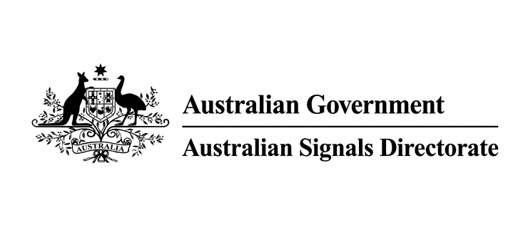
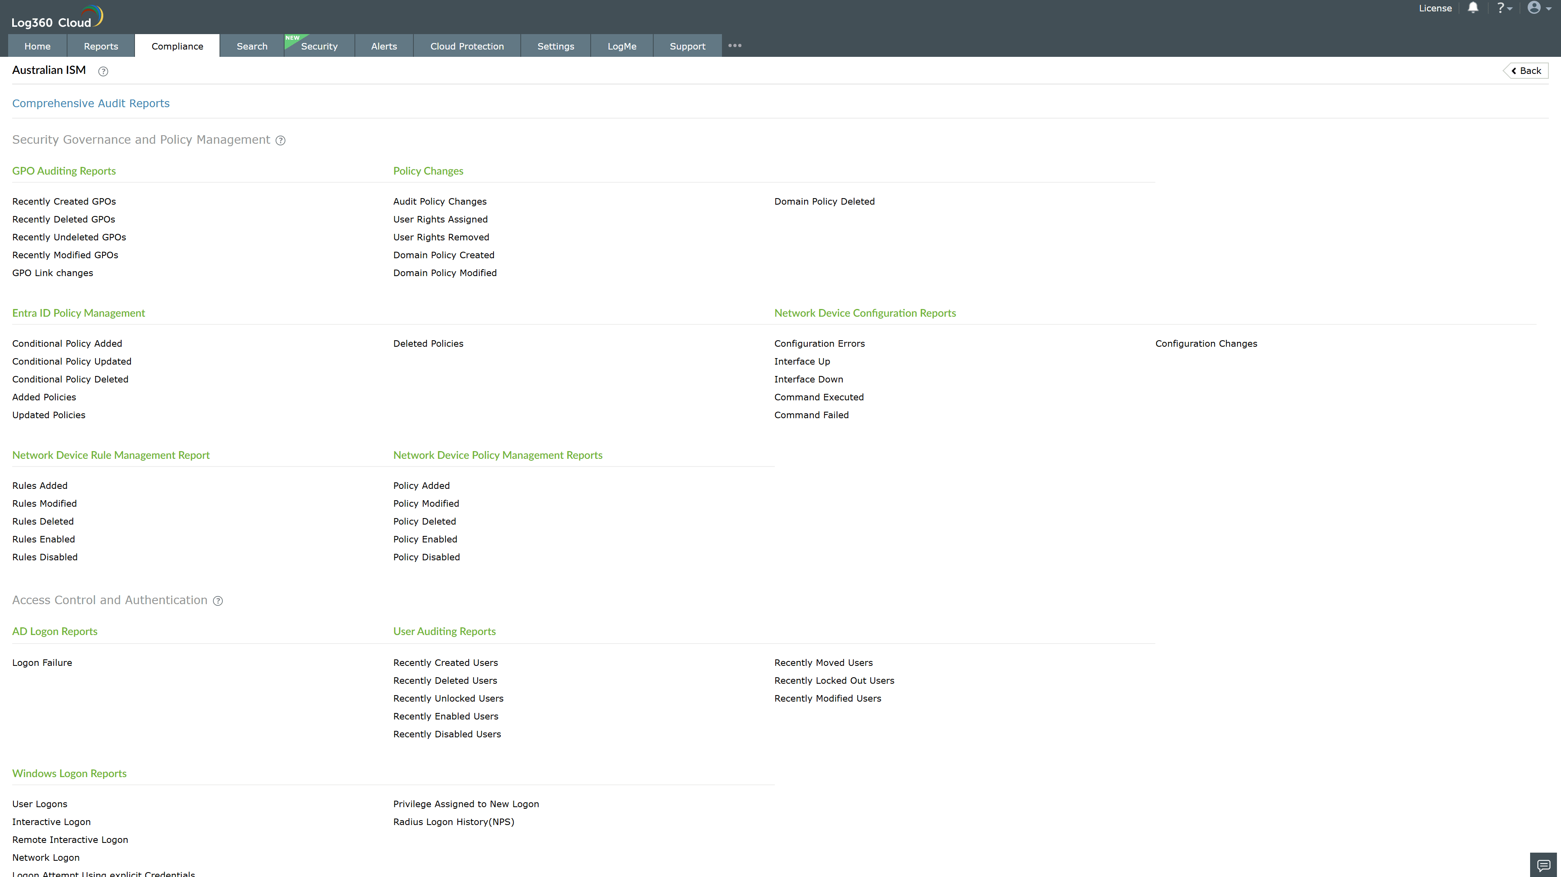
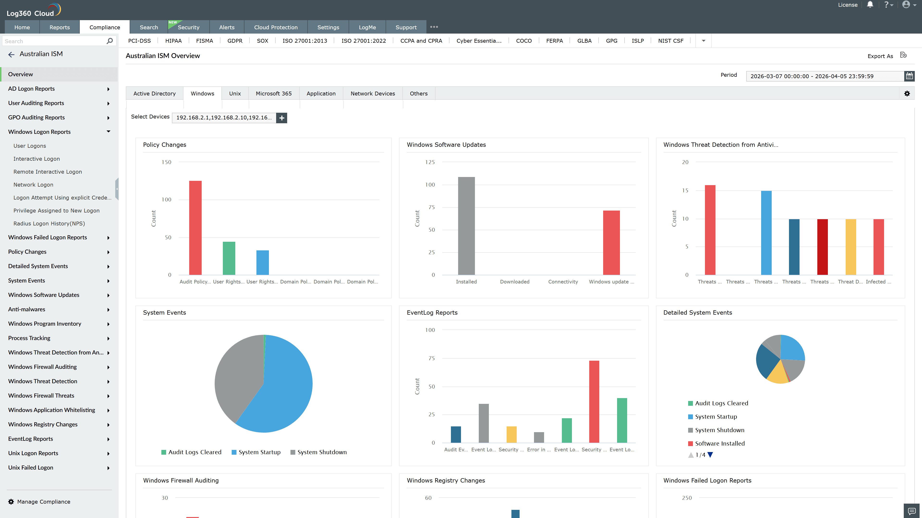
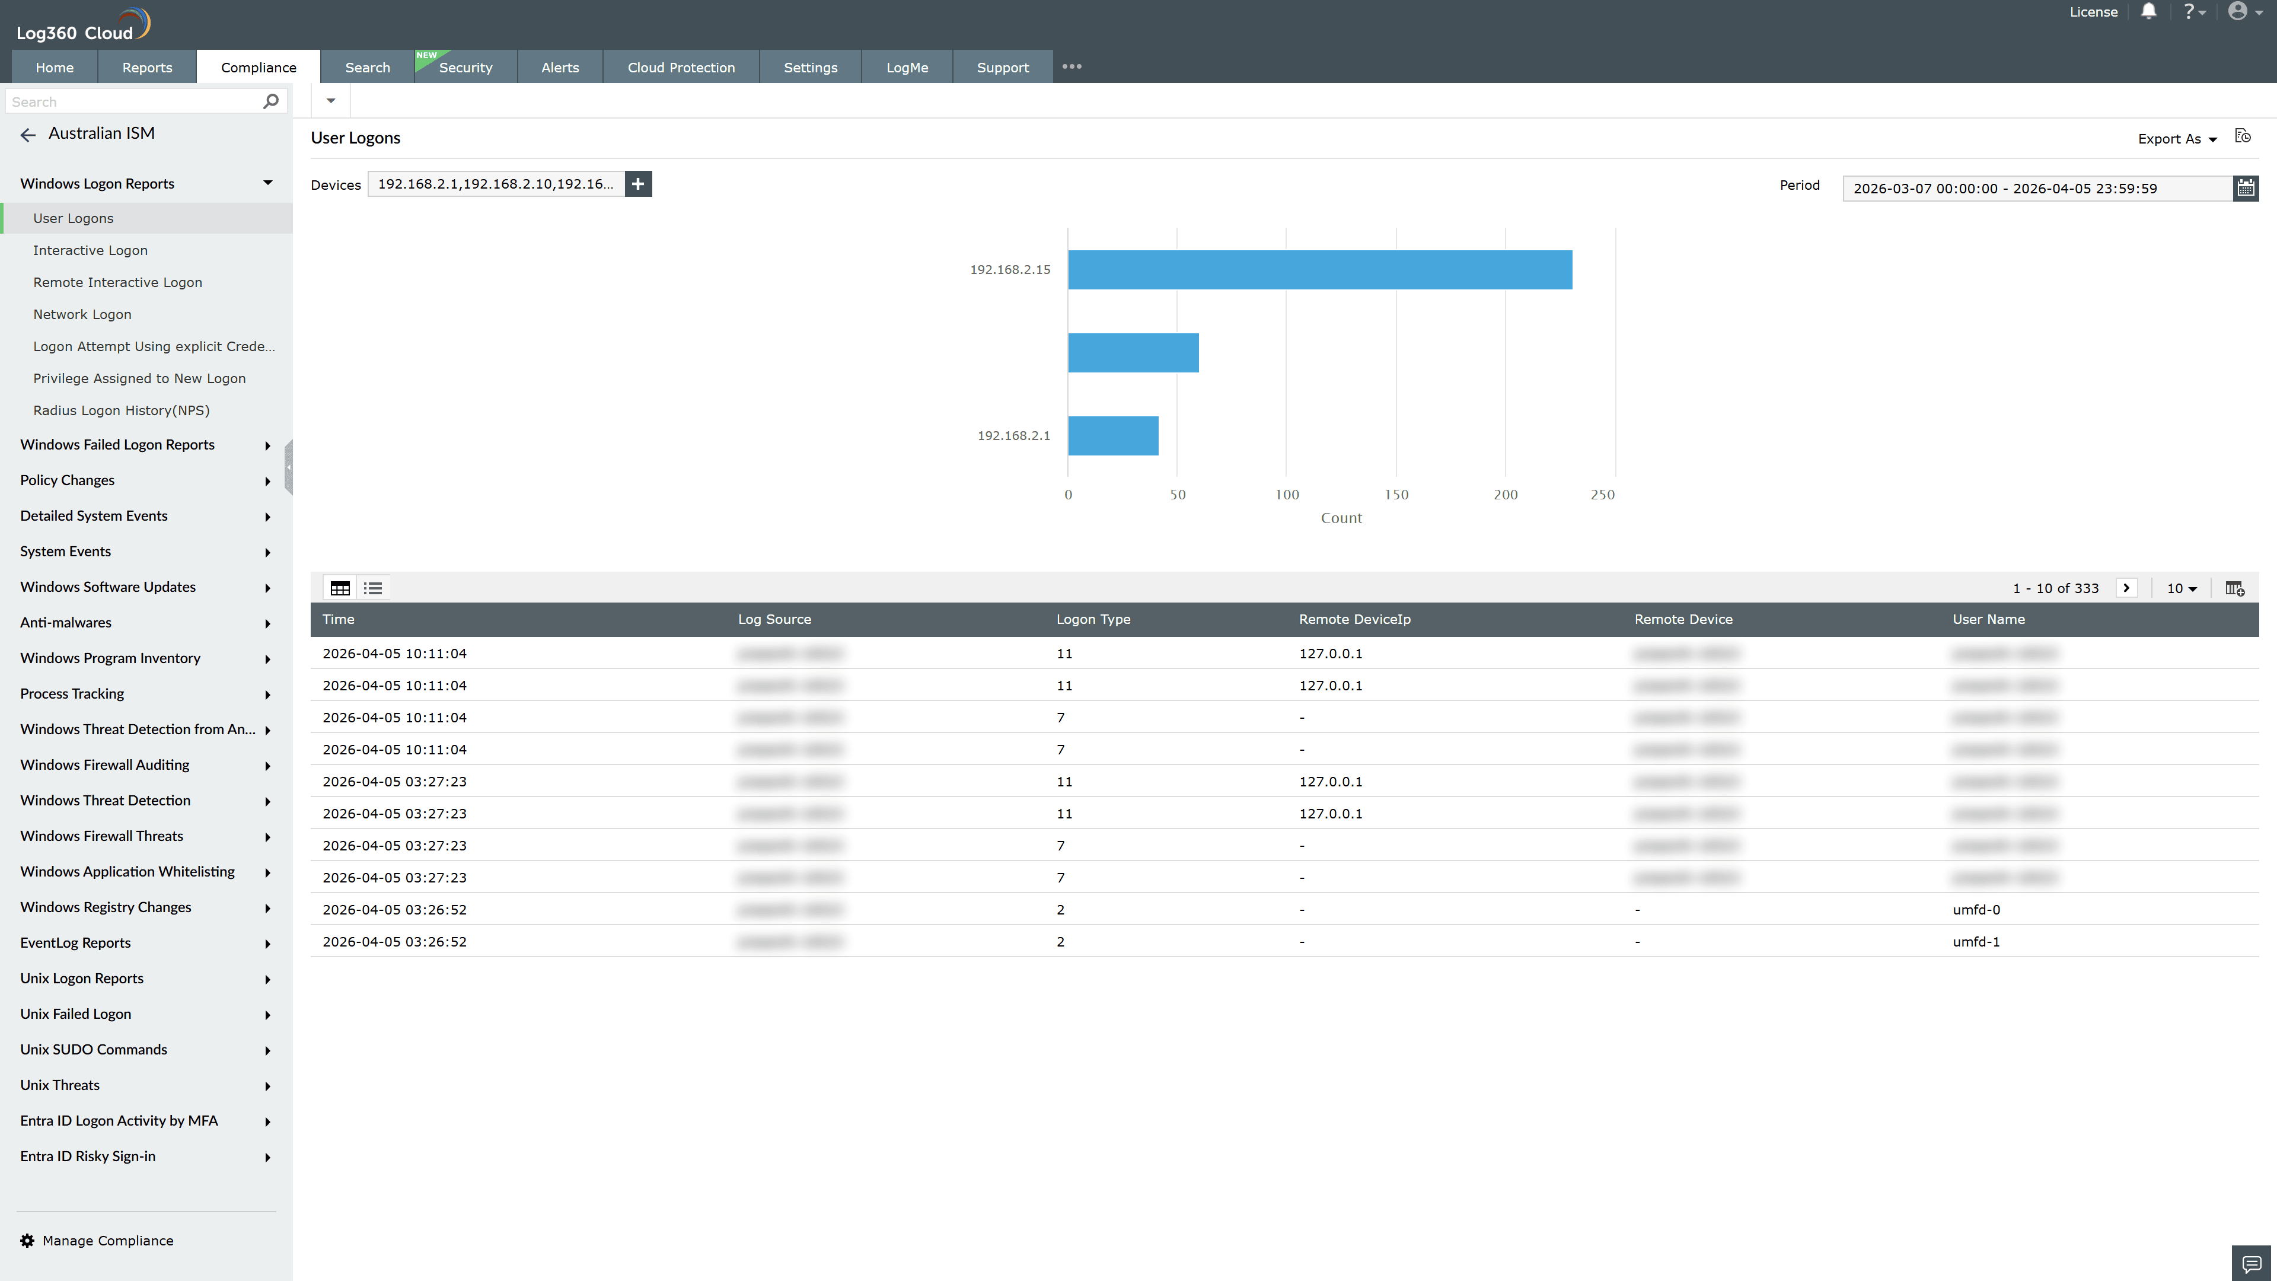
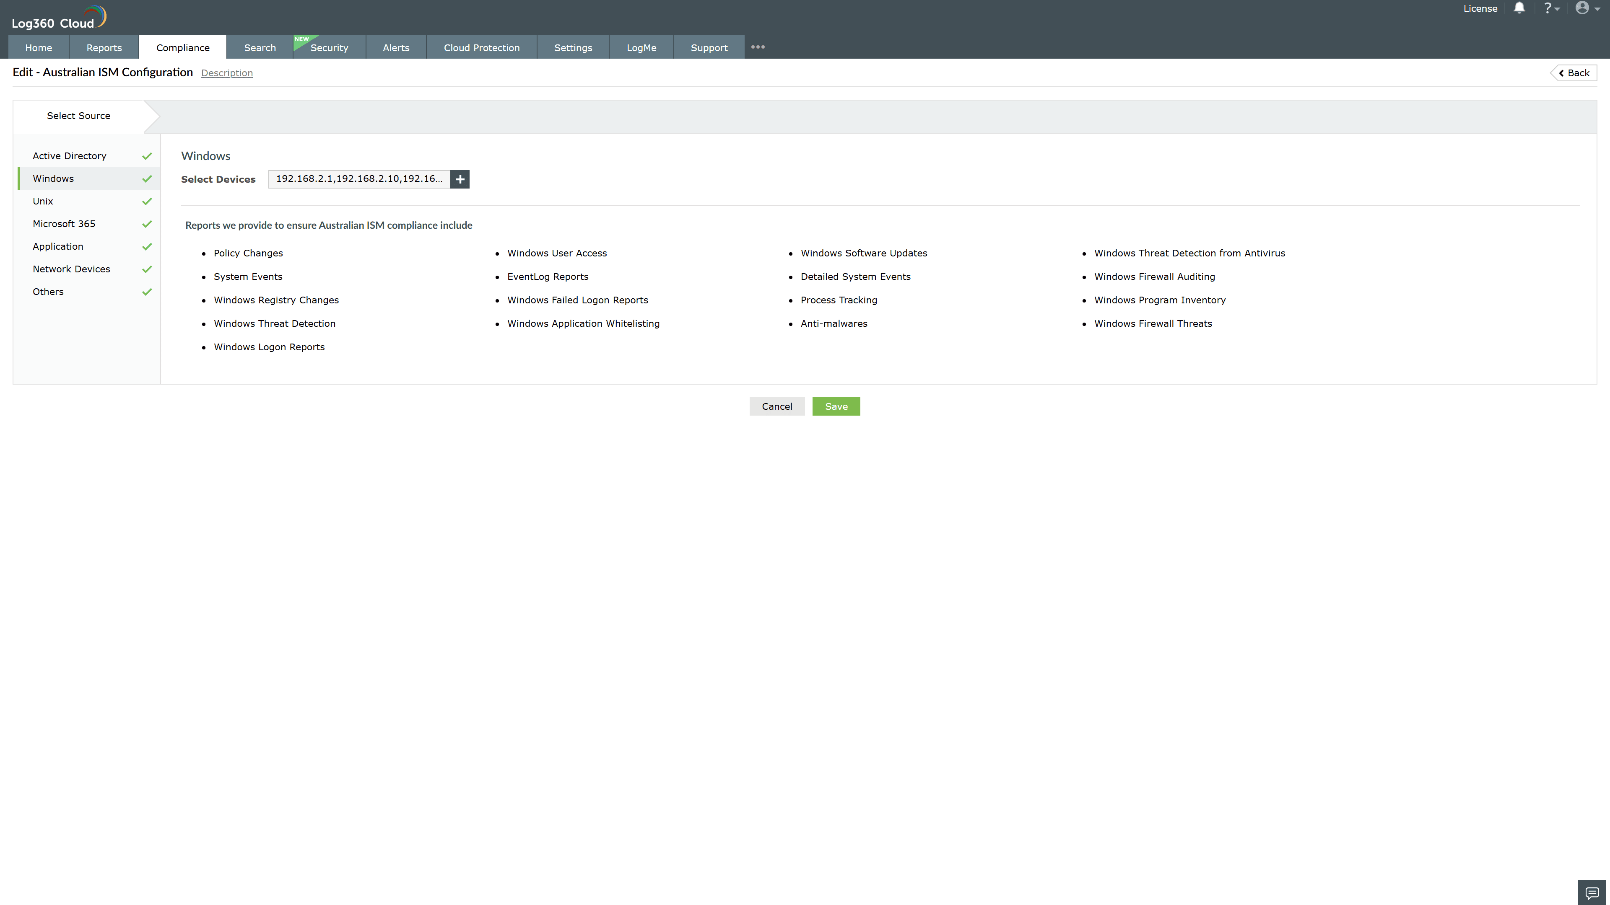
Valid Submission : Yes
Supported Editions : Free, Basic, Standard, Professional, MSSP
Help Document : https://www.manageengine.com/log-management/help/integrations/compliance-extensions.html
Help Video : Not provided
Tags : Log360, Compliance, Privacy monitoring, Data privacy, Regulatory compliance
Supported DCs : US, IN, JP, CA, AU, UK and EU
Privacy Policy:
Terms of Service:
Release Notes:
Predefined reports for the Australian ISM.

